The choice of the motor is carried out by evaluating the torque history in the centre of cam rotation.

****** grafico della coppia che non ho ******

Since the torque is not constant along the angular position of the cam, the minimum requirement for motor dimensioning should be:

$$\left\{\begin{aligned}T_{motor_{N}}> RMS_{torque} \\ T_{motor_\max{ }}>max⁡(torque_{load})\end{aligned}\right.$$

The valuea are:

* torque_max = 36.682 Nm
* RMS = 7.2 Nm

The rotation speed is 30 rpm so a gearbox (or a generic reduction) must be adopted, the value of tau is performed after the selection of the motor specific so for example by selecting the motor BLS-40 we have a

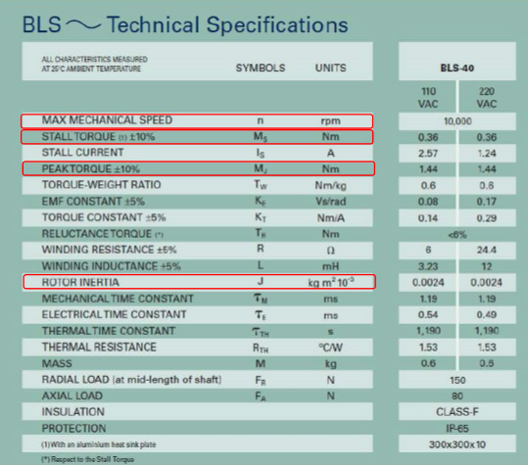stall torque of 0.36 (Nm) and a max torque of 1.44 (Nm). A value of reduction 1:28 is sufficient to maintain the maximum value of the torque under the peak of the motor and the RMS under the nominal torque of the motor. Instead if we want to over dimension the motor, a value of reduction 1:105 always maintains the nominal torque of the motor above the maximum load torque.